Course: COSC457.102 – Database Management Systems

Instructor: Leon Bernard

Room: YR- 304

Assignment #2 *(30 points)*

Please complete the following exercise from textbook

1. Exercise 3.21 - Design an ER schema for keeping track of information about votes taken in the U.S. House of Representatives during the current two-year congressional session. The database needs to keep track of each U.S. STATE’s Name (e.g., ‘Texas’, ‘New York’, ‘California’) and include the Region of the state (whose domain is {‘Northeast’, ‘Midwest’, ‘Southeast’, ‘Southwest’, ‘West’}). Each CONGRESS_PERSON in the House of Representatives is described by his or her Name, plus the District represented, the Start_date when the congressperson was first elected, and the political Party to which he or she belongs (whose domain is {‘Republican’, ‘Democrat’, ‘Independent’,‘Other’}). The database keeps track of each BILL (i.e., proposed law), including the Bill_name, the Date_of_vote on the bill, whether the bill Passed_or_failed (whose domain is {‘Yes’, ‘No’}), and the Sponsor (the congressperson(s) who sponsored—that is, proposed—the bill). The database also keeps track of how each congressperson voted on each bill (domain of Vote attribute is {‘Yes’, ‘No’, ‘Abstain’, ‘Absent’}).

Draw an ER schema diagram for this application. State clearly any assumptions you make. *(10 points)*

**Answer**

Additional information:

- There are 435 congresspersons in the U.S. House of Representatives.

- States have between one (AK, DE, MT, ND, SD, VT, and WY) and 52 (CA) representatives.

- M represents number of bills during the 2-year session.

The resulting ER Diagram is shown in Figure A.

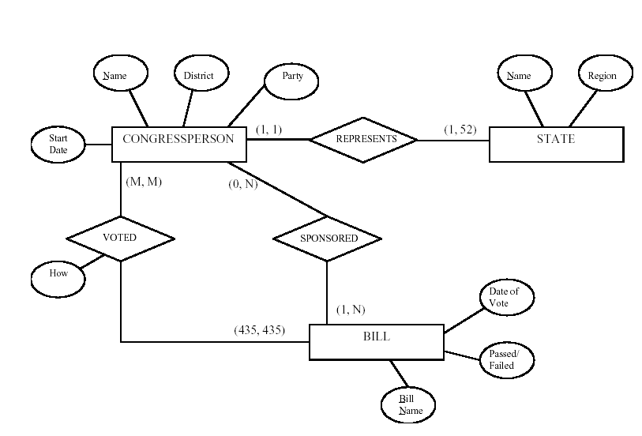

1. Exercise 3.23 - Consider the ER diagram shown in Figure 3.22 for part of a BANK database. Each bank can have multiple branches, and each branch can have multiple accounts and loans
   1. List the strong (nonweak) entity types in the ER diagram. *(1 point)*
   2. Is there a weak entity type? If so, give its name, partial key and identifying relationship. *(1 point)*
   3. What constraints do the partial key and the identifying relationship of the weak entity type specify in this diagram? *(1 point)*
   4. List the names of all relationship types, and specify the (min, max) constraint on each participation of an entity type in a relationship type. Justify your choices. *(2 points)*
   5. List concisely the user requirements that led to this ER schema design. *(3 points)*
   6. Suppose that every customer must have at least one account but is restricted to at most two loans at a time, and that a bank branch cannot have more than 1,000 loans. How does this show up on the (min, max) constraints? *(2 points)*

**Answer:**

(a) Entity types: BANK, ACCOUNT, CUSTOMER, LOAN

(b) Weak entity type: BANK-BRANCH. Partial key: BranchNo. Identifying relationship:

BRANCHES.

(c) The partial key BranchNo in BANK-BRANCH specifies that the same BranchNo value as occur under different BANKs. The identifying relationship BRANCHES specifies that BranchNo values are uniquely assigned for those BANK-BRANCH entities that are related to the same BANK entity. Hence, the combination of BANK Code and BranchNo together constitute a full identifier for a BANK-BRANCH.

(d) Relationship Types: BRANCHES, ACCTS, LOANS, A-C, L-C. The (min, max) constraints are shown below.

